
Sarhad College of Arts Commerece &

Science Katraj Pune-46
NAAC Accrediated with B+ Grade
(FACULTY OF SCIENCE & TECHNOLOGY)
Subject: Python Programming and Data Structure
MSc CA Sem-I

Name of the Student :- Tanuja Dilip Khandve

Roll No:- 2517011 Exam Seat No:- _____

SARHAD COLLEGE OF ARTS, COMMERCE AND SCIENCE KATRAJ, PUNE-46 (FACULTY OF SCIENCE & TECHNOLOGY)
Seat No:-

CERTIFICATE
This is informed that Miss /Mr/Mrs. Tanuja Dilip Khandve

Roll No. 2517011 From FYMSC-CA class has satisfactorily completed the laboratory course in Python Programming and Data structures subject during the year 2025-2026 as per the requirement of the university of Pune.
Date:-

Teacher In-charge HOD Principal
Internal Examiner External Examiner

INDEX
Sr. No. | Title | Page No. | Date | Sign
1 | Basic Python
2 | Python Tuples
3 | Python Sets
4 | Python Dictionary
5 | Python Array
6 | Python Functions
7 | Searching Algorithms
8 | Sorting Algorithms
9 | Singly Linked List
10 | Doubly Linked List
11 | Linked List Applications
12 | Stack | 13 |  | 10 | Doubly Linked List | 12
13 | Applications of Stack | 14 |  | 11 | Linked List Applications | 13
14 | Linear Queue | 15 |  |  | Stack | 13
15 | Circular and Priority Queue | 16
16 | Tree | 17
17 | Graph | 18

ASSIGNMENT NO 1:-
Q1: Write a Python Program to Calculate the Average of Numbers in a Given List.

numbers = [10, 20, 30, 40, 50]
average = sum(numbers) / len(numbers)
print("Average:", average)
Output:-
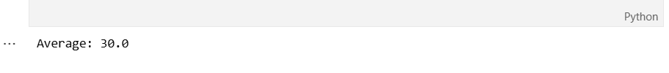

Q2: Write a program which accepts 6 integer values and prints "DUPLICATES" if any of the values entered are duplicates otherwise it prints "ALL UNIQUE".

values=[]

for i in range(6):
num=int(input(f"Enter integer {i+1}: "))
values.append(num)

if len(set(values))<len(values):
print("DUPLICATES")
else:
print("ALL UNIQUE")
Output:-
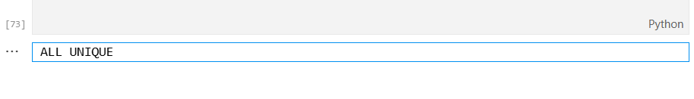

Q3: Write a program to display the following pattern:
1
2 3
4 5 6
7 8 9 10

n=1
for i in range(1,5):
for j in range(i):
print(n,end=" ")
n+=1
print()
Output:-
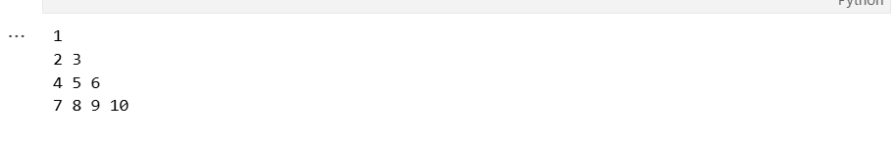

ASSIGNMENT NO 2 : - PYTHON TUPLES
Q1: Reverse the following tuple a Tup = (10, 20, 30, 40, 50)
python

Tup = (10, 20, 30, 40, 50)
print(Tup[::-1])
Output:-
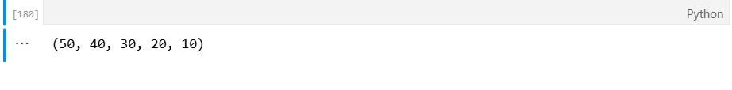

Q2: Write a Python program to Create a list of tuples with the first element as the number and second element as the square of the number.

result=[]
for i in range(1,6):
result.append((i,i*i))
print(result)
Output:-
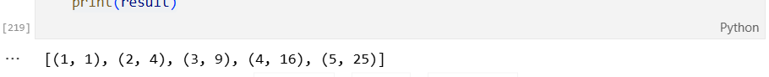

Q3.Copy element 44 and 55 from the following tuple into a new tuple tuple1 = (11, 22, 33, 44,
55, 66)

t = (11, 22, 33, 44, 55, 66)
new_t = (10,20,t[3], t[4],50)
print("Original Tuple:", t)
print("Copied Tuple: ",new_t)
Output:-
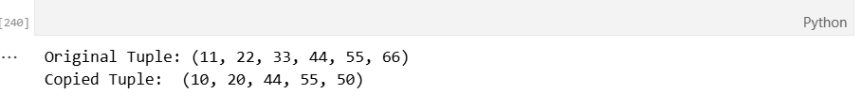

Q4: .Write a Python program to get the 5th element from front and 5th element from last of a tuple.

t = (1, 2, 3, 4, 5, 6, 7, 8, 9, 10)
print("5th from front:", t[4])
print("5th from last:", t[-5])

Output:-
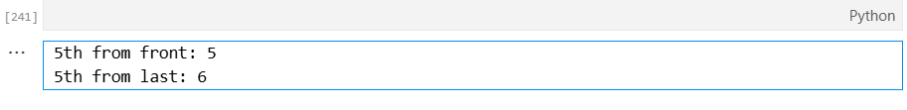

Q5. Write a Python program to find the repeated items of a tuple.

t=(10,20,20,30,40,40,50)
for item in set(t):
if t.count(item)>1:
print(item)
Output:-
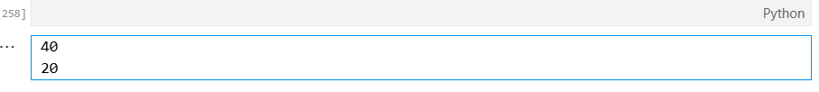
Q6. Write a Python program to check whether an element exists within a tuple.

t = (11, 22, 33, 44, 55, 66)
element = 55
print(element in t)
Output:-

ASSIGNMENT NO 3 : - PYTHON SETS
Q1: What is the output of following program: sets = {1, 2, 3, 4, 4} print(sets)

sets = {1, 2, 3, 4, 4}
print(sets) # Duplicate 4 is removed automatically
Output:-

Q2:Write a Python program to do iteration over sets.

s = {"apple", "banana", "cherry"}
for item in s:
print(item)
Output:-
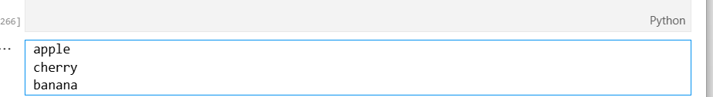

Q3: Write a Python program to add and remove operation on set.

s = {1, 2, 3}
print("Original set:", s)

# Add
s.add(4)
print("After adding 4:", s)

# Remove
s.remove(2)
print("After removing 2:", s)

Output:-
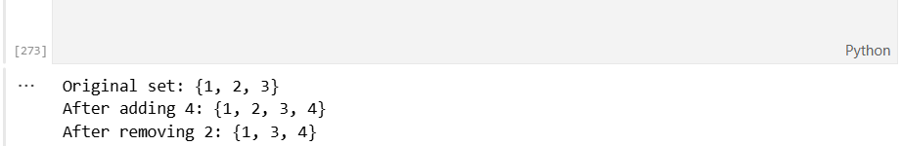

Q4: Write a Python program to find maximum and the minimum value in a set.

s = {10, 25, 5, 40, 15}
print("Maximum:", max(s))
print("Minimum:", min(s))
Output:-
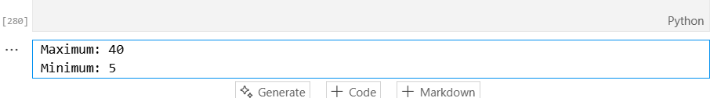

ASSIGNMENT NO 4 : - PYTHON DICTIONARY

Q1. Write a Python program to combine two dictionary adding values for common keys.
Sample Dictionary:
d1={'a':100,'b':200,'c':300}
d2={'a':300,'b':200,'d':400}

from collections import Counter

d1 = {'a': 100, 'b': 200, 'c': 300}
d2 = {'a': 300, 'b': 200, 'd': 400}

result = Counter(d1) + Counter(d2)
print(result)

Output:-
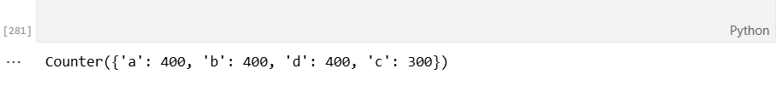
Q2. Write a Python script to generate and print a dictionary that contains a number (Between 1 and n) in the form (x, x*x).
Sample Dictionary (n = 5)
Expected Output : {1: 1, 2: 4, 3: 9, 4: 16, 5: 25}

n = int(input("Enter n: "))
square_dict = {x: x*x for x in range(1, n+1)}
print(square_dict)
Output:-
Q3: Write a Python program to create a dictionary from a string.
Sample-String: 'W3resource'
Expected output: {'3': 1, 's': 1, 'r': 2, 'u': 1, 'w': 1, 'c': 1, 'e': 2, 'o': 1}

string = "W3resource".lower()
char_count = {}
for char in string:
char_count[char] = char_count.get(char, 0) + 1
print(char_count)
Output:-
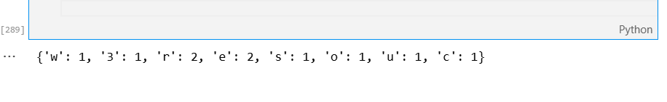

ASSIGNMENT NO 5: - PYTHON ARRAY
Q1: Write a python program to create an array of 5 integers and display the array elements. Access individual elements through indexes.

import array as arr

# Create an array of 5 integers
a = arr.array('i', [10, 20, 30, 40, 50])

# Display all elements
print("Array elements:", a)

# Access individual elements
print("First element:", a[0])
print("Second element:", a[1])
print("Third element:", a[2])
print("Fourth element:", a[3])
print("Fifth element:", a[4])
Output:-
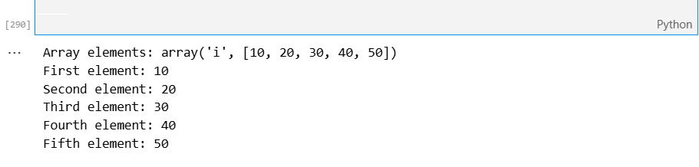
Q2: Write a python program to get the number of occurrences of specified elements in an array.

import array as arr

a = arr.array('i', [1, 2, 3, 2, 4, 2, 5])
element = int(input("Enter element to count: "))
count = a.count(element)
print(f"Number of occurrences of {element}:", count)

Output:-
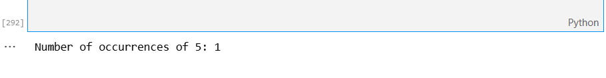
Q3: Write a python program to reverse the order of the items in the array.

import array as arr

a = arr.array('i', [1, 2, 3, 4, 5])
a.reverse()
print("Reversed array:", a)
Output:-

ASSIGNMENT NO 6: - PYTHON FUNCTIONS
Q1: Write a python function to sum of all the elements in a list.

def sum_list(lst):
return sum(lst)

# Example
numbers = [1, 2, 3, 4, 5]
print("Sum of list:", sum_list(numbers))
Output:-
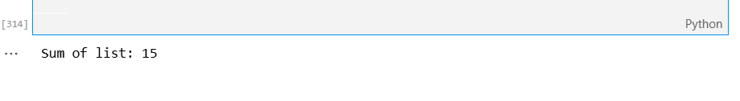
Q2: Write a python function to calculate the factorial of a number. The function accept the number as an argument.

def factorial(n):
fact = 1
for i in range(1, n+1):
fact *= i
return fact

# Example
num = int(input("Enter a number: "))
print("Factorial:", factorial(num))
Output:-
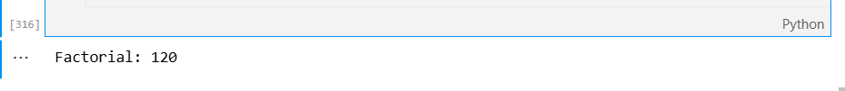

Q3: Write a python function to check whether a number falls within a given range.

def in_range(num, start, end):
return start <= num <= end

# Example
n = int(input("Enter number: "))
s = int(input("Enter range start: "))
e = int(input("Enter range end: "))
print("In range?", in_range(n, s, e))
Output:-
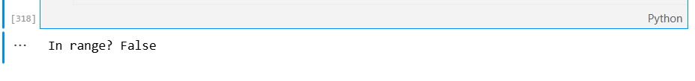

Q4: Write a python function that takes a list and returns a new list with distinct elements from the first list
Sample list: [1, 2 , 2, 3, 3, 3, 3, 4, 5]
Unique list: [1, 2, 3, 4, 5]

def unique_list(lst):
return list(set(lst))

# Example
sample = [1, 2, 2, 3, 3, 3, 3, 4, 5]
print("Sample list:", sample)
print("Unique list:", unique_list(sample))
Output:-
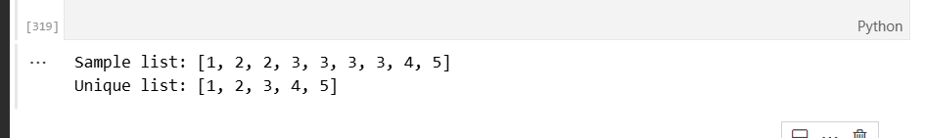

Data structures
ASSIGNMENT NO 7: SEARCHING ALGORITHMS
- Implementation of searching algorithms to search an element using: Linear Search, Binary Search.

# Linear Search
def linear_search(a, x):
for i in range(len(a)):
if a[i] == x:
return i
return -1

# Binary Search (sorted list required)
def binary_search(a, x):
low, high = 0, len(a)-1
while low <= high:
mid = (low+high)//2
if a[mid] == x:
return mid
elif a[mid] < x:
low = mid+1
else:
high = mid-1
return -1

nums = [5, 3, 7, 1, 9]
print("Linear Search:", linear_search(nums, 7))
print("Binary Search:", binary_search(sorted(nums), 7))
Output:-
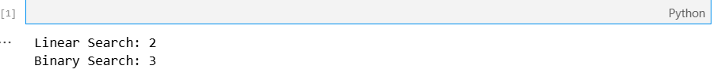

ASSIGNMENT NO 8: SORTING ALGORITHMS

Q1: Implement Bubble Sort, Insertion Sort, Quick Sort, Merge Sort.

def bubble_sort(a):
for i in range(len(a)):
for j in range(len(a)-i-1):
if a[j] > a[j+1]: a[j], a[j+1] = a[j+1], a[j]
return a

def insertion_sort(a):
for i in range(1, len(a)):
k, j = a[i], i-1
while j >= 0 and a[j] > k:
a[j+1] = a[j]; j -= 1
a[j+1] = k
return a

def quick_sort(a):
return a if len(a) <= 1 else quick_sort([x for x in a[1:] if x <= a[0]]) + [a[0]] + quick_sort([x for x in a[1:] if x > a[0]])

def merge_sort(a):
if len(a) <= 1: return a
l, r = merge_sort(a[:len(a)//2]), merge_sort(a[len(a)//2:])
res=[]
while l and r: res.append((l if l[0] < r[0] else r).pop(0))
return res+l+r

nums = [5, 2, 9, 1, 7]
print("Bubble:", bubble_sort(nums[:]))
print("Insertion:", insertion_sort(nums[:]))
print("Quick:", quick_sort(nums[:]))
print("Merge:", merge_sort(nums[:]))

Output:-
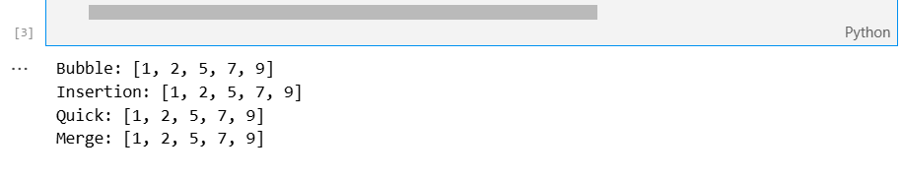

ASSIGNMENT NO 9:

Q1: Singly Linked List -1. Dynamic implementation of Singly Linked List to
perform following operations:
1.Create, Insert, Delete, Display, Search, Reverse
2. Create a list in the sorted order.

class Node:
def __init__(self, data):
self.data = data
self.next = None

class SinglyLinkedList:
def __init__(self):
self.head = None

def create(self, data_list):
for data in data_list:
self.insert_end(data)

def insert_end(self, data):
new_node = Node(data)
if not self.head:
self.head = new_node
return
temp = self.head
while temp.next:
temp = temp.next
temp.next = new_node

def delete(self, key):
temp = self.head
if temp and temp.data == key:
self.head = temp.next
return
prev = None
while temp and temp.data != key:
prev = temp
temp = temp.next
if temp:
prev.next = temp.next

def search(self, key):
temp = self.head
while temp:
if temp.data == key:
return True
temp = temp.next
return False

def reverse(self):
prev = None
current = self.head
while current:
nxt = current.next
current.next = prev
prev = current
current = nxt
self.head = prev

def display(self):
temp = self.head
while temp:
print(temp.data, end=" -> ")
temp = temp.next
print("None")

# Example usage
ll = SinglyLinkedList()
ll.create([10, 20, 30])
print("Original list:")
ll.display()
ll.insert_end(40)
print("After inserting 40:")
ll.display()
ll.delete(20)
print("After deleting 20:")
ll.display()
print("Search 30:", ll.search(30))
ll.reverse()
print("After reversing:")
ll.display()

Output:-
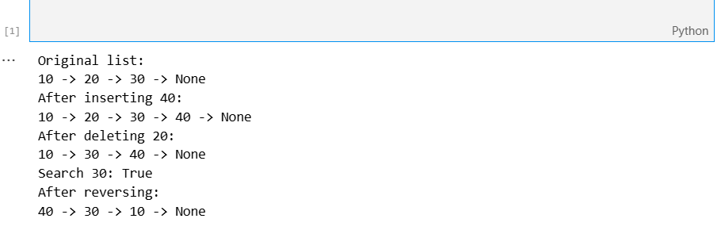

Assignment 10:

Doubly Linked List - Dynamic implementation of Doubly circular Linked List to perform following operations: Create, Insert, Delete, Display, Search

class Node:
def __init__(self, data):
self.data = data
self.prev = None
self.next = None

class DoublyCircularLinkedList:
def __init__(self):
self.head = None

def create(self, data_list):
for data in data_list:
self.insert_end(data)

def insert_end(self, data):
new_node = Node(data)
if not self.head:
self.head = new_node
self.head.next = self.head
self.head.prev = self.head
return
tail = self.head.prev
tail.next = new_node
new_node.prev = tail
new_node.next = self.head
self.head.prev = new_node

def delete(self, key):
if not self.head:
return
curr = self.head
while True:
if curr.data == key:
if curr.next == curr: # only one node
self.head = None
return
curr.prev.next = curr.next
curr.next.prev = curr.prev
if curr == self.head:
self.head = curr.next
return
curr = curr.next
if curr == self.head:
break

def display(self):
if not self.head:
print("List is empty")
return
curr = self.head
while True:
print(curr.data, end=" ")
curr = curr.next
if curr == self.head:
break
print()

def search(self, key):
if not self.head:
return False
curr = self.head
while True:
if curr.data == key:
return True
curr = curr.next
if curr == self.head:
break
return False

# Example
dll = DoublyCircularLinkedList()
dll.create([10, 20, 30])
dll.display()
dll.insert_end(40)
dll.display()
dll.delete(20)
dll.display()
print("Search 30:", dll.search(30))
print("Search 50:", dll.search(50))
Output:-
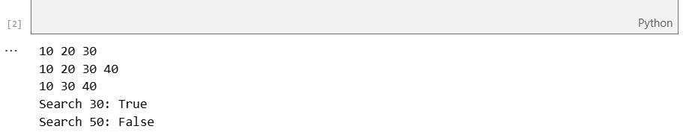

ASSIGNMENT 11:
Linked List Applications - Merge two sorted lists.

class Node:
def __init__(self, data):
self.data = data
self.next = None

def merge_sorted_lists(l1, l2):
dummy = Node(0)
tail = dummy
while l1 and l2:
if l1.data < l2.data:
tail.next = l1
l1 = l1.next
else:
tail.next = l2
l2 = l2.next
tail = tail.next
tail.next = l1 or l2
return dummy.next

def display(head):
while head:
print(head.data, end=" -> ")
head = head.next
print("None")

# Example
a = Node(1); a.next = Node(3); a.next.next = Node(5)
b = Node(2); b.next = Node(4); b.next.next = Node(6)

print("List 1:")
display(a)
print("List 2:")
display(b)

merged = merge_sorted_lists(a, b)
print("Merged List:")
display(merged)
Output:-
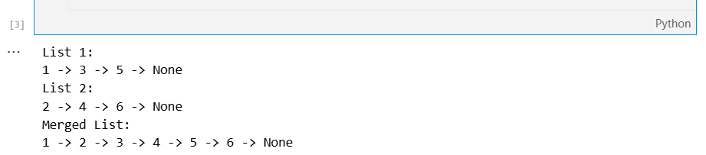

ASSIGNMENT 12:

Stack - Static and Dynamic implementation of Stack to perform following
operations: Init, Push, Pop, Isempty, Isfull

# Assignment 6: Static & Dynamic Stack

# ---------- Static Stack ----------
class StaticStack:
def __init__(self, size):
self.stack = []
self.size = size

def push(self, item):
if self.is_full():
print("Static Stack is FULL")
else:
self.stack.append(item)

def pop(self):
if self.is_empty():
print("Static Stack is EMPTY")
else:
return self.stack.pop()

def is_empty(self):
return len(self.stack) == 0

def is_full(self):
return len(self.stack) == self.size

# ---------- Dynamic Stack ----------
class DynamicStack:
def __init__(self):
self.stack = []

def push(self, item):
self.stack.append(item)

def pop(self):
if self.is_empty():
print("Dynamic Stack is EMPTY")
else:
return self.stack.pop()

def is_empty(self):
return len(self.stack) == 0

# ---------- Demo ----------
# Static Stack
s1 = StaticStack(3)
s1.push(10)
s1.push(20)
s1.push(30)
s1.push(40) # Will show FULL
print("Static Pop:", s1.pop())

# Dynamic Stack
s2 = DynamicStack()
s2.push(100)
s2.push(200)
s2.push(300)
print("Dynamic Pop:", s2.pop())
Output:-
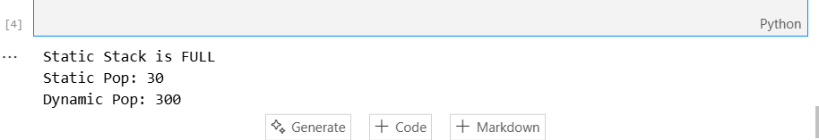

Assignment 13:
Applications of Stack –
1. Implementation of an algorithm that reverses string of characters using stack and checks whether a string is a palindrome.
2. Infix to Postfix conversion. Evaluation of postfix expression

# Assignment 7: Applications of Stack

class Stack:
def __init__(self):
self.items = []

def push(self, item):
self.items.append(item)

def pop(self):
return self.items.pop()

def peek(self):
return self.items[-1]

def is_empty(self):
return len(self.items) == 0

# 1. Reverse string and check palindrome
def reverse_string(s):
st = Stack()
for ch in s:
st.push(ch)
rev = ""
while not st.is_empty():
rev += st.pop()
return rev

def is_palindrome(s):
return s == reverse_string(s)

# 2. Infix to Postfix conversion
def infix_to_postfix(expression):
precedence = {'+':1, '-':1, '*':2, '/':2, '^':3}
st = Stack()
output = ""
for ch in expression:
if ch.isalnum():
output += ch
elif ch == '(':
st.push(ch)
elif ch == ')':
while not st.is_empty() and st.peek() != '(':
output += st.pop()
st.pop()
else: # operator
while (not st.is_empty()) and st.peek() != '(' and precedence[ch] <= precedence[st.peek()]:
output += st.pop()
st.push(ch)
while not st.is_empty():
output += st.pop()
return output

# 3. Postfix Evaluation
def eval_postfix(expression):
st = Stack()
for ch in expression:
if ch.isdigit():
st.push(int(ch))
else:
b = st.pop()
a = st.pop()
if ch == '+': st.push(a + b)
elif ch == '-': st.push(a - b)
elif ch == '*': st.push(a * b)
elif ch == '/': st.push(a // b)
return st.pop()

# ---- MAIN ----
# Reverse & Palindrome
s = "madam"
rev = reverse_string(s)
print("Original:", s)
print("Reversed:", rev)
print("Palindrome?", is_palindrome(s))

# Infix to Postfix + Evaluation
infix_exp = "3+(2*4)"
postfix_exp = infix_to_postfix(infix_exp)
print("\nInfix:", infix_exp)
print("Postfix:", postfix_exp)
print("Postfix Evaluation:", eval_postfix(postfix_exp))
Output:-
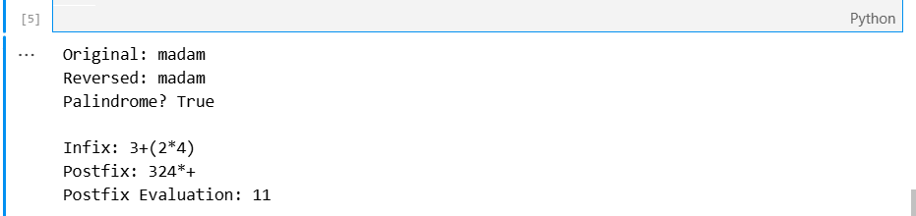

Assignment 14:

Linear Queue - Static and Dynamic implementation of linear Queue to perform following operations: Init, enqueue, dequeue, IsEmpty, IsFull.

# Assignment 8: Linear Queue - Static & Dynamic Implementation
##########SLIP NO 1 Q2 STATIC implementation
# ----- Static Queue Implementation -----
class StaticQueue:
def __init__(self, size):
self.size = size
self.queue = [None] * size
self.front = 0
self.rear = -1

def isEmpty(self):
return self.front > self.rear

def isFull(self):
return self.rear == self.size - 1

def enqueue(self, item):
if self.isFull():
print("Static Queue is Full!")
else:
self.rear += 1
self.queue[self.rear] = item
print(f"Enqueued: {item}")

def dequeue(self):
if self.isEmpty():
print("Static Queue is Empty!")
else:
item = self.queue[self.front]
self.front += 1
print(f"Dequeued: {item}")

# ----- Dynamic Queue Implementation -----
class DynamicQueue:
def __init__(self):
self.queue = []

def isEmpty(self):
return len(self.queue) == 0

def enqueue(self, item):
self.queue.append(item)
print(f"Enqueued: {item}")

def dequeue(self):
if self.isEmpty():
print("Dynamic Queue is Empty!")
else:
item = self.queue.pop(0)
print(f"Dequeued: {item}")

# ----- Main Program -----
print("----- Static Queue -----")
sq = StaticQueue(3)
sq.enqueue(10)
sq.enqueue(20)
sq.enqueue(30)
sq.enqueue(40) # Overflow
sq.dequeue()
sq.dequeue()
sq.dequeue()
sq.dequeue() # Underflow

print("\n----- Dynamic Queue -----")
dq = DynamicQueue()
dq.enqueue(100)
dq.enqueue(200)
dq.enqueue(300)
dq.dequeue()
dq.dequeue()
dq.dequeue()
dq.dequeue() # Underflow
Output:-
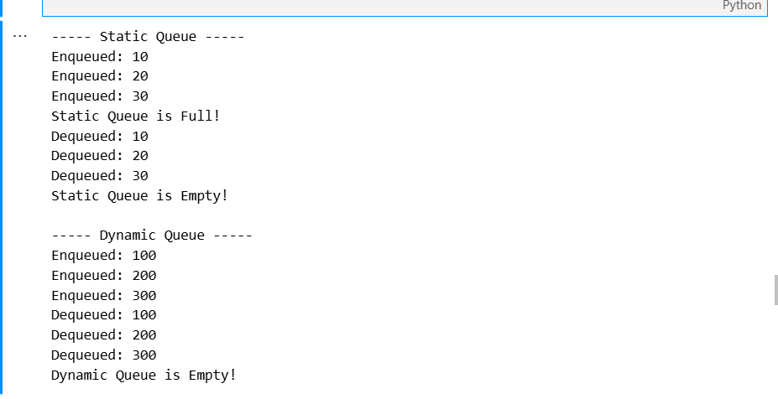

Assignment 15:

Circular and Priority Queue
1. Implementation of circular queue
2. Implementation of priority queue

# ----- Circular Queue Implementation -----
class CircularQueue:
def __init__(self, size):
self.size = size
self.queue = [None] * size
self.front = self.rear = -1 ## IT means queue is empty

def isEmpty(self):
return self.front == -1

def isFull(self):
return (self.rear + 1) % self.size == self.front ## IT means queue is full How to check if queue is full that is rear+1 is equal to front

def enqueue(self, item):
if self.isFull():
print("Circular Queue is Full!")
else:
if self.front == -1:
self.front = 0
self.rear = (self.rear + 1) % self.size
self.queue[self.rear] = item
print(f"Enqueued: {item}")

def dequeue(self):
if self.isEmpty():
print("Circular Queue is Empty!")
else:
item = self.queue[self.front]
if self.front == self.rear:
self.front = self.rear = -1
else:
self.front = (self.front + 1) % self.size
print(f"Dequeued: {item}")

# ----- Priority Queue Implementation -----
class PriorityQueue:
def __init__(self):
self.queue = []

def isEmpty(self):
return len(self.queue) == 0

def enqueue(self, item, priority):
self.queue.append((priority, item))
self.queue.sort(reverse=True) # Higher priority first
print(f"Enqueued: {item} with priority {priority}")

def dequeue(self):
if self.isEmpty():
print("Priority Queue is Empty!")
else:
priority, item = self.queue.pop(0)
print(f"Dequeued: {item} with priority {priority}")

# ----- Main Program -----
print("----- Circular Queue -----")
cq = CircularQueue(3)
cq.enqueue(1)
cq.enqueue(2)
cq.enqueue(3)
cq.enqueue(4) # Overflow
cq.dequeue()
cq.enqueue(4)
cq.dequeue()
cq.dequeue()
cq.dequeue()
cq.dequeue() # Underflow

print("\n----- Priority Queue -----")
pq = PriorityQueue()
pq.enqueue("Apple", 2)
pq.enqueue("Banana", 1)
pq.enqueue("Cherry", 3)
pq.dequeue()
pq.dequeue()
pq.dequeue()
pq.dequeue() # Underflow
Output:-
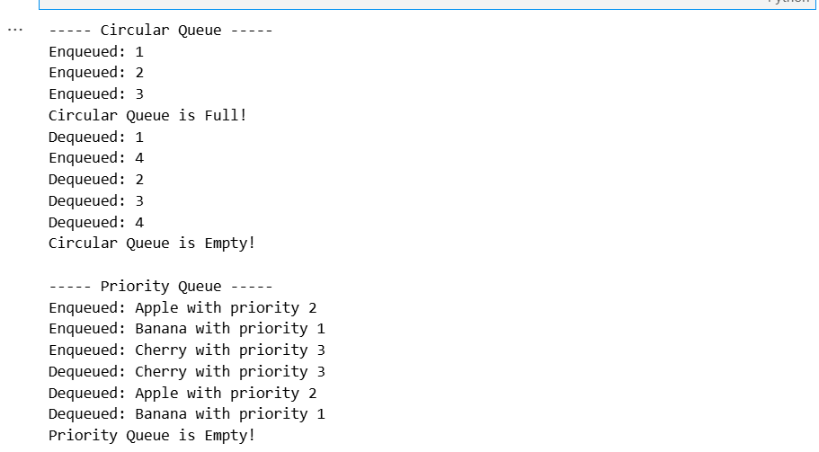

Assignment 16:

Tree Travarsals, operations etc

# Assignment 10: Tree Traversals and Operations

class Node:
def __init__(self, key):
self.key = key
self.left = None
self.right = None

# ----- Insertion in Binary Tree -----
def insert(root, key):
if root is None:
return Node(key)
if key < root.key:
root.left = insert(root.left, key)
else:
root.right = insert(root.right, key)
return root

# ----- Inorder Traversal (LNR) -----
def inorder(root):
if root:
inorder(root.left)
print(root.key, end=" ")
inorder(root.right)

# ----- Preorder Traversal (NLR) -----
def preorder(root):
if root:
print(root.key, end=" ")
preorder(root.left)
preorder(root.right)

# ----- Postorder Traversal (LRN) -----
def postorder(root):
if root:
postorder(root.left)
postorder(root.right)
print(root.key, end=" ")

# ----- Search in Binary Tree -----
def search(root, key):
if root is None:
return False
if root.key == key:
return True
elif key < root.key:
return search(root.left, key)
else:
return search(root.right, key)

# ----- Main Program -----
root = None
values = [50, 30, 20, 40, 70, 60, 80]

for v in values:
root = insert(root, v)

print("Inorder Traversal:")
inorder(root)
print("\nPreorder Traversal:")
preorder(root)
print("\nPostorder Traversal:")
postorder(root)

print("\n\nSearching 40:", "Found" if search(root, 40) else "Not Found")
print("Searching 100:", "Found" if search(root, 100) else "Not Found")

Output:-
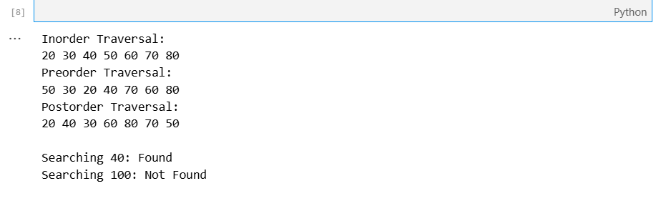

Assignment 17 :
Calculate indegree and out degree of a given graph

# Assignment 11: Calculate indegree and outdegree of a given graph

# Function to calculate indegree and outdegree
def calculate_degrees(graph):
vertices = list(graph.keys())
indegree = {v: 0 for v in vertices}
outdegree = {v: len(graph[v]) for v in vertices}

# Calculate indegree
for v in vertices:
for neighbor in graph[v]:
indegree[neighbor] += 1

return indegree, outdegree

# ----- Main Program -----
# Graph representation as adjacency list
graph = {
'A': ['B', 'C'],
'B': ['C'],
'C': ['A'],
'D': ['C']
}

print("Graph:", graph)

indegree, outdegree = calculate_degrees(graph)

print("\nVertex\tIndegree\tOutdegree")
for vertex in graph:
print(f"{vertex}\t{indegree[vertex]}\t\t{outdegree[vertex]}")
Output:-
